K-Nearest Neighbors Classifier
Codecademy movies (from-scratch) + Wisconsin breast-cancer (sklearn) · short name KNN_Cancer

Problem Statement
A new row — movie, biopsy, or loan file — has numbers and no label. KNN asks which labeled points sit closest and what those neighbors vote. Two traps: raw scales are incomparable (budget drowns year), and k is a bias–variance knob (k=1 copies outliers; huge k copies the base rate). This project votes by hand on 40 films, then scores 569 Wisconsin cells (30 features, 212 malignant / 357 benign) while k, scaling, noise, n, and junk columns change.

Solution Strategy
Euclidean distance in n-D (Manhattan alternate). Min-max each column on the training fold only. Take the k smallest distances; majority wins (odd k avoids ties). Same pipeline via KNeighborsClassifier. Stratified 80/20, seed 100. Sweep k=1…50. A 2-D blob set shows the jagged k=1 vs smooth k=21 boundary; a DTI/utilization book is extra practice. Simulation knobs: k, label flips, training fraction, padded noise columns. Four audience rewrites in the memo.

Solution
Check | Result | Note
Star Wars vs Raiders (2-D) | d ≈ 10.77 | Closer than Mean Girls (year + runtime)
Cancer split | 455 / 114 | test_size=0.2, seed=100, stratified
k = 3 unscaled | 0.939 | Radius / texture ranges dominate
k = 3 min-max scaled | 0.965 | Every feature contributes fairly
Best scaled k | k = 15 → 0.974 | 114 hold-out cells
+80 noise columns | ~0.91 | Curse of dimensionality
Validation accuracy vs k (min-max scaled vs raw features). Companion panel: knn_cancer_simulation.png.
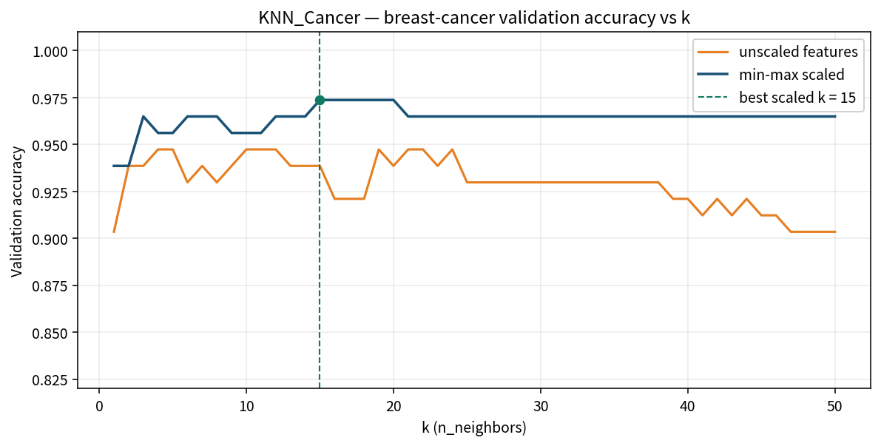

Key Takeaways
- Closeness is a distance over all features — not the “most important” column and not a shared-feature count.
- Normalize first. Unscaled budget or cell-area will quietly own the neighbor list.
- Small k overfits (outliers vote); large k underfits (global majority). Accuracy vs k rises then falls.
- Odd k removes 2–2 ties. sklearn.predict takes a batch of new points, not the training matrix.
- KNN still “works” at 30 features; stuffing 80 noise columns makes distances look alike and accuracy drops.
- This is a triage aid. A 97% hold-out score is not a signed pathology report.

